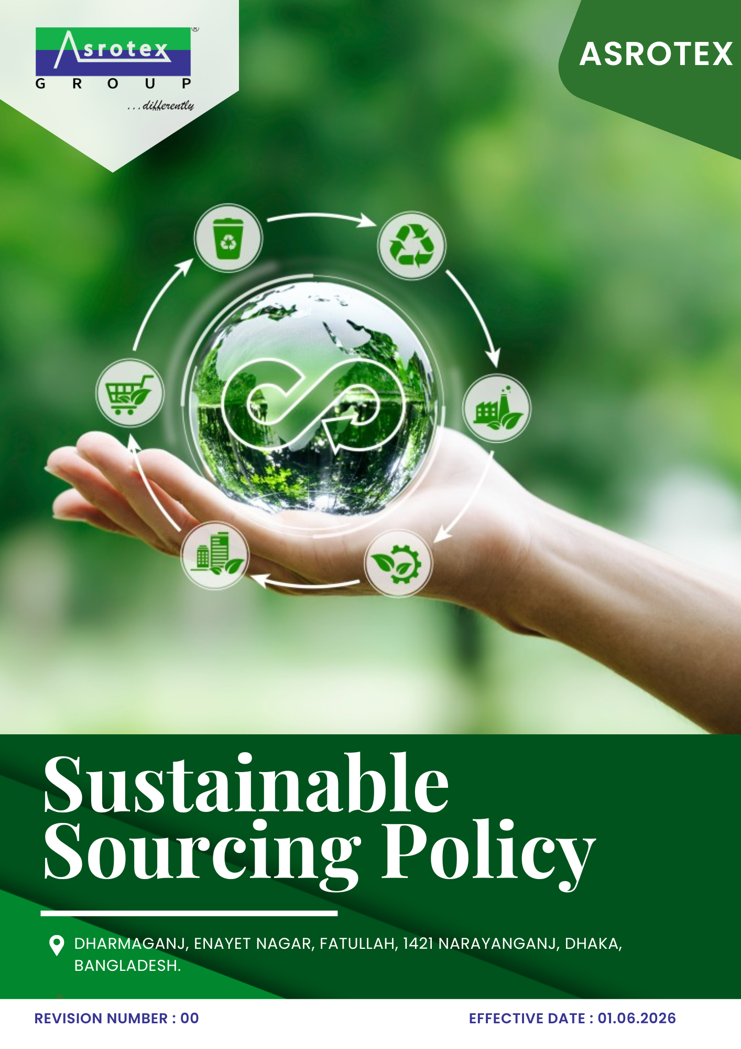

TABLE OF CONTENTS
Asrotex — Sustainable Sourcing Policy
01 Preface 3
02 Purpose 3
03 Scope 3
04 Sustainable Sourcing Commitments 3
05 Roles & Responsibilities 4
06 Initiatives and Targets 5
07 Sustainable Sourcing Performance, Monitoring & Reporting 7
08 Supplier Risk Assessment and Due Diligence 7
09 Addressing Supplier non-compliance 8
10 Review Mechanism & Continual Improvement 9
Annexure A – United Nations Sustainable Development Goals (UNSDGs) 10
Employee Acknowledgment 11

01 Preface
Asrotex is committed to integrating sustainability into its procurement and supply chain management practices. We recognize that responsible sourcing plays a vital role in creating long-term value by promoting ethical business conduct, environmental stewardship, respect for labour and human rights, and resilient supplier relationships.
This Sustainable Sourcing Policy establishes the framework for incorporating environmental, social, and ethical considerations into procurement decisions and supplier engagement activities. Through responsible supplier selection, continuous performance evaluation, collaboration, and continual improvement, Asrotex aims to build a sustainable and transparent supply chain that supports responsible business growth while meeting the expectations of customers, stakeholders, and applicable regulatory requirements.

02 Purpose
The purpose of this Sustainable Sourcing Policy is to establish a framework for integrating environmental, social, ethical, and governance (ESG) considerations into Asrotex's procurement and supply chain management practices. The policy aims to promote responsible sourcing, strengthen supplier sustainability performance, ensure ethical and transparent procurement practices, and drive continual improvement across the Company's supply chain.

03 Scope
Sr. No. | Site | Address
1 | Asrotex | Dharmaganj, Enayet Nagar, Fatullah, 1421 Narayanganj, Dhaka, Bangladesh.
This Sustainable Sourcing Policy applies to all procurement and sourcing activities carried out at the following operational location of Asrotex:

This policy covers the procurement of raw materials, packaging materials, consumables, machinery, equipment, services, and other goods required for the Company's operations. It applies to all employees involved in procurement and supplier management, as well as suppliers, contractors, service providers, agents, and other business partners engaged in activities on behalf of Asrotex. The policy also establishes the framework for integrating environmental, social, ethical, and governance (ESG) considerations into supplier selection, evaluation, and ongoing business relationships.

04 Sustainable Sourcing Commitments
Asrotex is committed to:
- Integrating environmental, social, ethical, and governance (ESG) considerations into procurement and supplier management practices.
- Conducting procurement activities with integrity, transparency, fairness, and accountability while preventing conflicts of interest, bribery, and other unethical practices.
- Building long-term partnerships with suppliers through collaboration, capacity building, and continual improvement of sustainability performance.
- Assessing and managing sustainability risks across the supply chain through appropriate due diligence, monitoring, and performance evaluations.
- Encouraging suppliers and business partners to comply with applicable legal requirements, internationally recognized sustainability principles, and Asrotex's responsible sourcing expectations.
Unless otherwise specified, 2023 has been established as the baseline year for measuring sustainable sourcing performance and tracking progress against the objectives and targets defined in this policy.

05 Roles & Responsibilities
The successful implementation of this Sustainable Sourcing Policy requires the commitment and active participation of all personnel involved in procurement and supplier management at Asrotex. Responsibilities are assigned as follows:
Managing Director
- Provide leadership and strategic direction for sustainable sourcing and responsible supply chain management.
- Ensure adequate resources are available to implement this policy and achieve its objectives.
Procurement Department
- Integrate sustainability requirements into supplier selection, evaluation, contracting, and procurement decisions.
- Monitor supplier performance and promote continual improvement in sustainable sourcing practices.
- Conduct procurement activities ethically, transparently, and in accordance with this policy.
- Report any concerns relating to supplier performance, unethical conduct, or non-compliance through the established reporting channels.
Department Heads
- Ensure procurement activities within their respective departments comply with this policy and support the achievement of sustainable sourcing objectives and targets.
- Promote collaboration with suppliers to strengthen environmental, social, and ethical performance.
Suppliers, Contractors & Business Partners
- Comply with Asrotex's sustainable sourcing requirements and applicable legal and regulatory obligations.
- Cooperate in sustainability assessments, due diligence activities, and continual improvement initiatives to strengthen responsible supply chain performance.

06 Initiatives and Targets
1 Environmental Sustainability in the Supply Chain

Objective
To promote environmentally responsible procurement practices.

Initiatives
- Integrate environmental sustainability criteria into supplier selection, evaluation, and procurement decisions.
- Encourage suppliers to improve environmental performance through responsible resource management, waste reduction, and emission control practices.
- Promote the procurement of sustainable, certified, recycled, and lower-impact materials, where feasible.
- Collaborate with suppliers to strengthen environmental performance and support continual improvement across the supply chain.
TARGET
Ensure 80% of suppliers implement environmental management practices or hold recognized environmental certifications by year 2030.
Conduct environmental sustainability assessments for 100% of suppliers by 2030.
Close corrective action plans for 100% of strategic suppliers identified with significant environmental risks within the agreed timeframe by 2030.
2 Labour & Human Rights in the Supply Chain

Objective
To promote responsible sourcing by ensuring suppliers uphold internationally recognized labour and human rights principles throughout the supply chain.

Initiatives
- Integrate labour and human rights requirements into supplier selection, evaluation, and ongoing performance monitoring.
- Promote supplier awareness of ethical labour practices through engagement, communication, and capacity-building initiatives.
- Encourage suppliers to establish effective grievance mechanisms and periodically assess compliance with labour and human rights requirements.

TARGET
Provide labour and human rights awareness programmes to 100% of key suppliers by 2030
Ensure 100% of key suppliers comply with Asrotex's minimum labour and human rights requirements by 2030 through supplier audits and assessments.
Implement corrective action plans for 100% of suppliers identified with significant labour and human rights non-conformities within the agreed timeframe.
3 Supplier Engagement and Capacity Building
Objective
To strengthen supplier sustainability performance by promoting collaboration, knowledge sharing, and continuous capacity building across the supply chain.
Initiatives
- Develop long-term supplier partnerships based on transparency, collaboration, and shared sustainability objectives.
- Encourage suppliers to adopt internationally recognized management systems and sustainability certifications relevant to their operations.
- Conduct supplier engagement programmes to communicate Asrotex's sustainability expectations and emerging ESG requirements.
- Support suppliers through guidance, communication, and improvement initiatives to enhance sustainability performance.
TARGET
Conduct at least two supplier engagement or sustainability awareness programmes annually.
Recognize the top-performing 5% of suppliers annually based on sustainability performance.
Engage 80% of suppliers in supplier sustainability or capacity-building programmes by 2030.
4 Supplier Inclusivity
Objective
To promote an inclusive and resilient supply chain by providing equitable procurement opportunities and encouraging supplier diversity.
- Encourage participation of local, small, and diverse suppliers in procurement opportunities, where feasible.
- Promote fair and transparent supplier selection processes based on objective evaluation criteria.
- Support capable small and medium-sized enterprises (SMEs) in strengthening their sustainability performance.
TARGET
Maintain equal opportunity and transparent evaluation criteria for 100% of supplier selection processes annually.
Increase procurement from local, diverse, or small and medium-sized suppliers to 10% of applicable procurement by 2030.
5 Ethical Sourcing
Objective
To promote ethical procurement practices by ensuring integrity, transparency, accountability, and responsible business conduct throughout the supply chain.
Initiatives
- Encourage suppliers to adopt ethical business practices, governance systems, and whistleblower mechanisms.
- Periodically monitor supplier compliance with ethical sourcing requirements and support continual improvement.
TARGET
Conduct ethical sourcing assessments for 100% of high-risk suppliers by 2030.
Ensure 100% of procurement personnel receive ethical sourcing and anti-corruption training annually.

07 Sustainable Sourcing Performance, Monitoring & Reporting
Asrotex is committed to regularly monitoring and evaluating its sustainable sourcing performance to ensure the effective implementation of this policy and the achievement of its objectives and targets.
The Company shall:
- Monitor key sustainable sourcing performance indicators, including supplier sustainability performance, responsible procurement, supplier assessments, corrective actions, supplier engagement, and ethical sourcing practices.
- Maintain accurate procurement and supplier sustainability records and periodically review performance against established sustainable sourcing objectives and targets.
- Conduct supplier assessments, internal reviews, and performance evaluations to identify opportunities for improvement and implement appropriate corrective and preventive actions.
- Report sustainable sourcing performance to management and relevant stakeholders, where applicable, to support transparency, responsible procurement, and continual improvement across the supply chain.

08 Supplier Risk Assessment and Due Diligence
Asrotex is committed to continuously monitoring supplier sustainability performance to strengthen responsible sourcing practices and improve supply chain resilience. Supplier performance shall be evaluated through a structured due diligence process that considers environmental, social, ethical, legal, and operational performance.
The Supplier ESG Performance Monitoring Programme includes:
- Periodic supplier sustainability assessments based on defined ESG evaluation criteria.
- Review of supplier compliance with applicable legal requirements, customer expectations, and contractual sustainability commitments.
- Risk-based supplier classification to identify suppliers requiring enhanced monitoring or additional support.
- Monitoring of corrective action plans and verification of timely closure of identified non-conformities.
- Review of supplier certifications, audit findings, sustainability disclosures, and performance indicators.
- Periodic management review of supplier sustainability performance to support procurement decisions and continuous improvement.
- Collaboration with suppliers to encourage innovation, responsible sourcing practices, and long-term sustainability improvements across the supply chain.
The outcomes of supplier monitoring shall be incorporated into procurement planning, supplier development programmes, contract renewal decisions, and future sourcing strategies to ensure continual enhancement of Asrotex's sustainable sourcing performance.

09 Addressing Supplier non-compliance
Asrotex expects all suppliers to comply with the principles outlined in this Policy. Where non-compliance is identified, the Company shall adopt a structured and fair approach to encourage timely improvement while protecting the integrity of the supply chain.
Where appropriate, Asrotex may:
- Communicate identified non-compliance issues to the supplier.
- Request corrective and preventive action plans with defined implementation timelines.
- Conduct follow-up assessments or verification activities to evaluate improvement.
- Provide guidance or technical support where feasible to strengthen supplier performance.
- Increase monitoring frequency for suppliers presenting elevated sustainability risks.
- Suspend new business opportunities where significant issues remain unresolved.
- Discontinue business relationships where serious or repeated violations occur and adequate corrective actions are not implemented.
All supplier non-compliance cases shall be documented, reviewed, and managed in accordance with established procurement and compliance procedures.

10 Review Mechanism & Continual Improvement
This Sustainable Sourcing Policy shall be reviewed biennially, or earlier if required due to changes in applicable legal requirements, business operations, supplier expectations, customer requirements, or other relevant factors.
Asrotex shall periodically evaluate the effectiveness of this policy, review progress against its sustainable sourcing objectives and targets, and implement necessary improvements to strengthen responsible procurement practices and supplier sustainability performance. The outcomes of these reviews shall be considered when updating the policy and supporting the Company's commitment to continual improvement across the supply chain.
Rev. No.  00 | Effective Date  01.01.2026 | Next Review Date  01.01.2028
Approved By:

Annexure A – United Nations Sustainable Development Goals (UNSDGs)
Asrotex recognizes the importance of integrating responsible sourcing principles into its procurement and supply chain management practices. The commitments, objectives, and initiatives outlined in this policy contribute to the following United Nations Sustainable Development Goals (UNSDGs):
UN SDG | Key Focus Area | Relevant Policy Sections
SDG 8 – Decent Work and Economic Growth | Responsible procurement, fair labour practices, ethical supplier management, and sustainable economic growth | Labour & Human Rights in the Supply Chain; Supplier Engagement & Capacity Building
SDG 10 – Reduced Inequalities | Inclusive procurement and equal opportunities for diverse suppliers | Supplier Inclusivity
SDG 12 – Responsible Consumption and Production | Sustainable procurement, responsible material sourcing, and resource efficiency | Environmental Sustainability in the Supply Chain
SDG 13 – Climate Action | Environmental performance improvement and climate-conscious procurement practices | Environmental Sustainability in the Supply Chain
SDG 16 – Peace, Justice and Strong Institutions | Ethical sourcing, anti-corruption, transparency, and responsible business conduct | Ethical Sourcing & Responsible Business Conduct; Roles & Responsibilities
SDG 17 – Partnerships for the Goals | Supplier collaboration, capacity building, and sustainable supply chain partnerships | Supplier Engagement & Capacity Building; Sustainable Sourcing Performance, Monitoring & Reporting

Employee Acknowledgment
I acknowledge that I have received, read, and understood the Sustainable Sourcing Policy of Asrotex. I understand my responsibilities under this policy and agree to comply with its requirements while performing my duties.
I am committed to supporting the Company's sustainable sourcing objectives by conducting procurement activities with integrity, promoting responsible supplier relationships, and encouraging environmental, social, and ethical practices throughout the supply chain. I further agree to report any concerns or suspected non-compliance through the established reporting channels.
Name:
Position:
Signature:
Date:

